SOUND BAR DATASET ANALYSIS USING MACHINE LEARNING

CONTEXT
OBJECTIVE: To design and implement a comprehensive machine learning system for the analysis of soundbar products, leveraging data collected through web scraping from an e-commerce platform and stored in MySQL database, the system applies both unsupervised and supervised learning techniques to enable automated product classification, category prediction and market segmentation, Encompassing data acquisition, preprocessing, exploratory analysis, clustering, predictive modelling and evaluation to generate actionable insights and enhance product intelligence.

SCOPE: Scope of this project encompasses several key objectives aimed at enhancing the understanding and classification of soundbar products within the consumer electronics market. Specifically, the project aims to,
- Automate soundbar product classification
- Enable market segmentation based on product features
- Evaluate performance across multiple supervised models
- Utilize unsupervised learning to uncover natural groupings
- Provide actionable insights for consumer electronics market analysis

AUDIENCE: Project presents a practical and scalable framework for applying data-driven techniques in the consumer electronics domain, specifically focusing on soundbar products. The target audience are,
- E-commerce Product Teams in optimizing product recommendations
- Marketing and Business Strategists
- Machine Learning Practitioners
- Assist retail businesses
ANALYSIS
DATA COLLECTION: Soundbar product data was collected by web scraping filtered brand-specific listings from the Amazon e-commerce platform. Using Python libraries such as requests and BeautifulSoup, 2860 records were extracted with initial attributes including product name, brand, price and ratings. To enhance the dataset, additional features were derived from the unstructured product names regular expressions. Key attributes extracted included wattage, channel configuration, wireless capability, smart assistance presence, Dolby support, and connectivity options. These transformations expanded the dataset to 12 - 15 columns, forming a rich foundation for machine learning analysis.

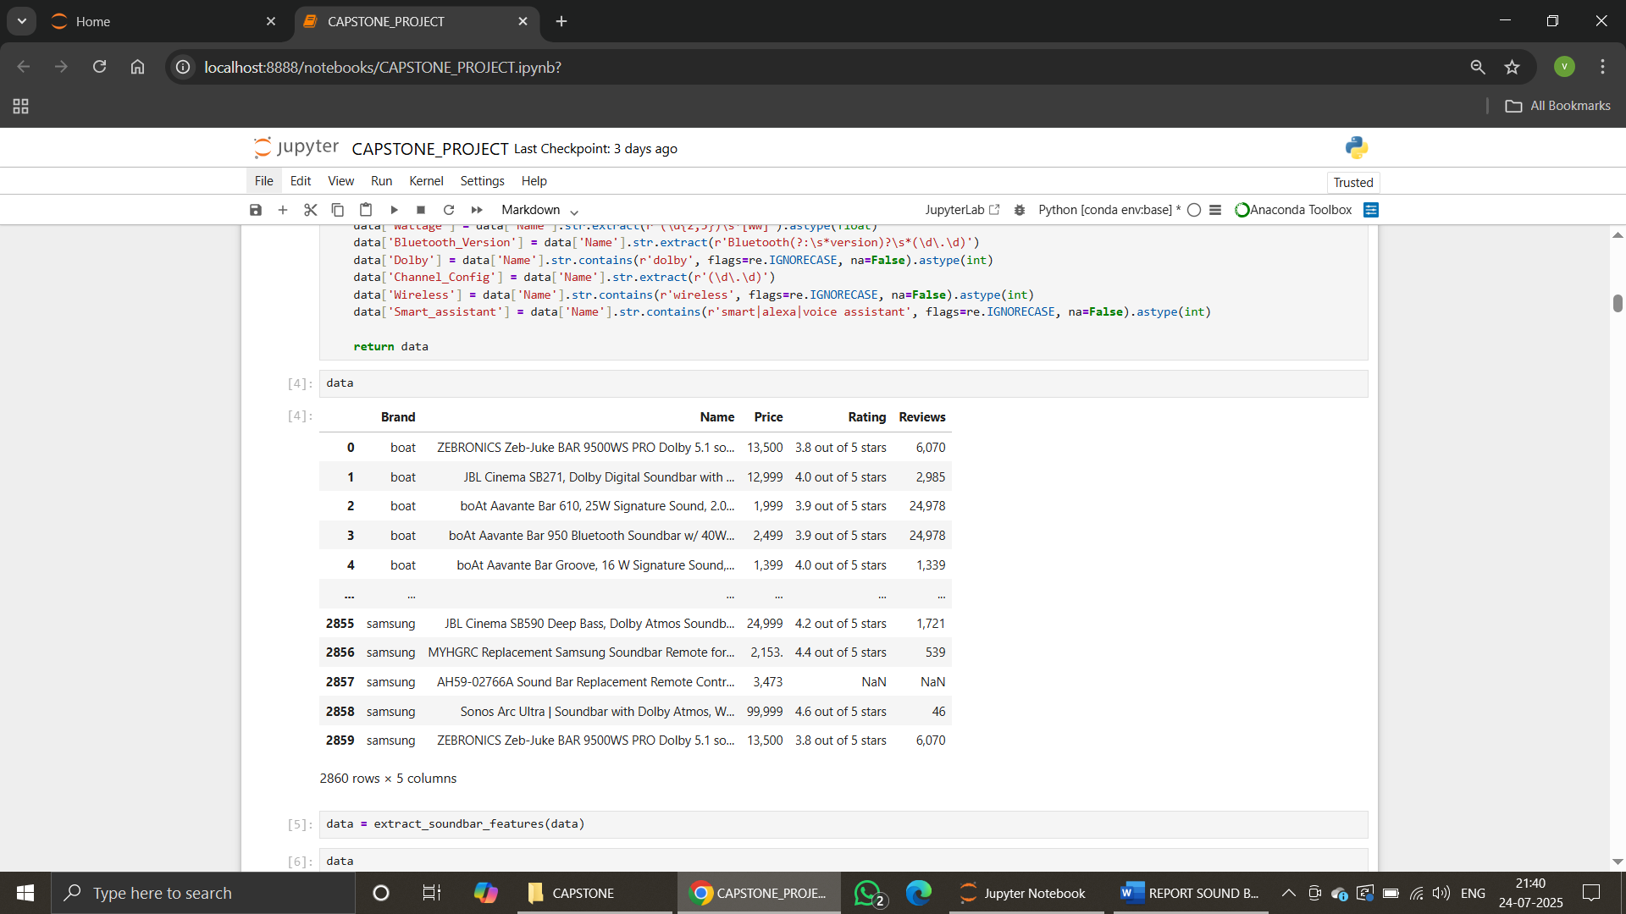

DATA CLEANING: The soundbar dataset underwent thorough preprocessing to ensure data quality and readiness for machine learning. Missing values in key fields like price and ratings were dropped. Duplicates were removed based on product name, brand and price. Unstructured product names were parsed using regular expressions to extract features such as wattage, channel configuration, wireless terms and subwoofer presence. Ratings embedded in text were extracted as numeric values. Relevant columns were converted to appropriate data types and unnecessary columns were removed. Outliers in price, wattage and ratings were identified via boxplots and was excluded to reduce noise.
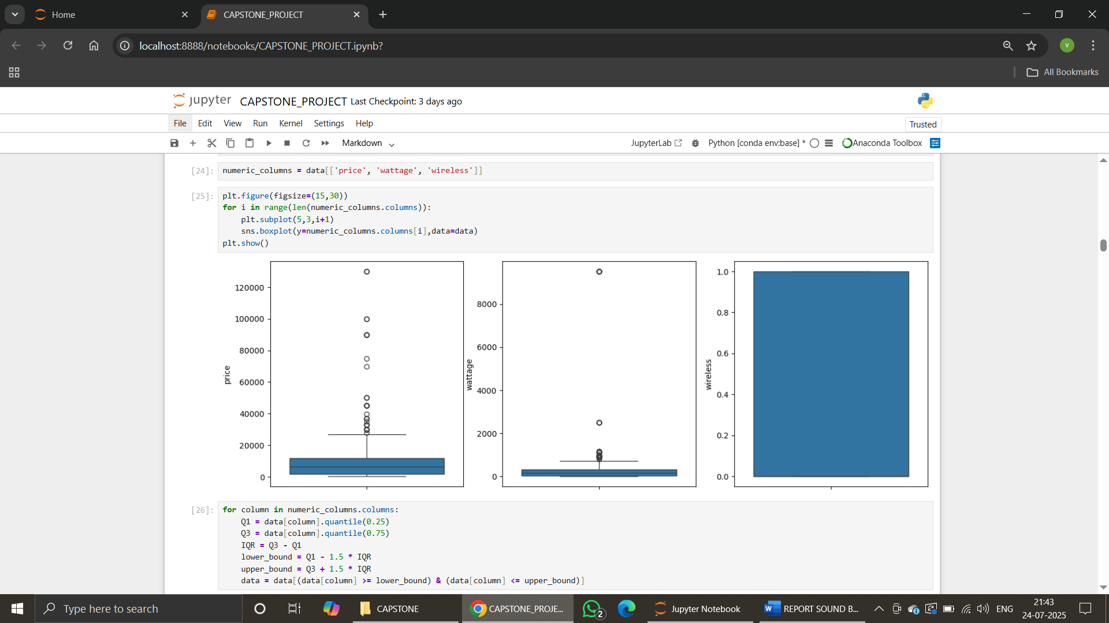

DATA STORAGE AND RETRIVAL: To ensure data persistence, scalability, and structured access, the collected data was stored in a MySQL relational database. This setup allowed efficient querying, backup and data integrity. Using Python libraries like SQLAlchemy and PyMySQL, SQL queries were executed to retrieve the data into a Pandas DataFrame for preprocessing, exploratory analysis and further machine learning tasks.
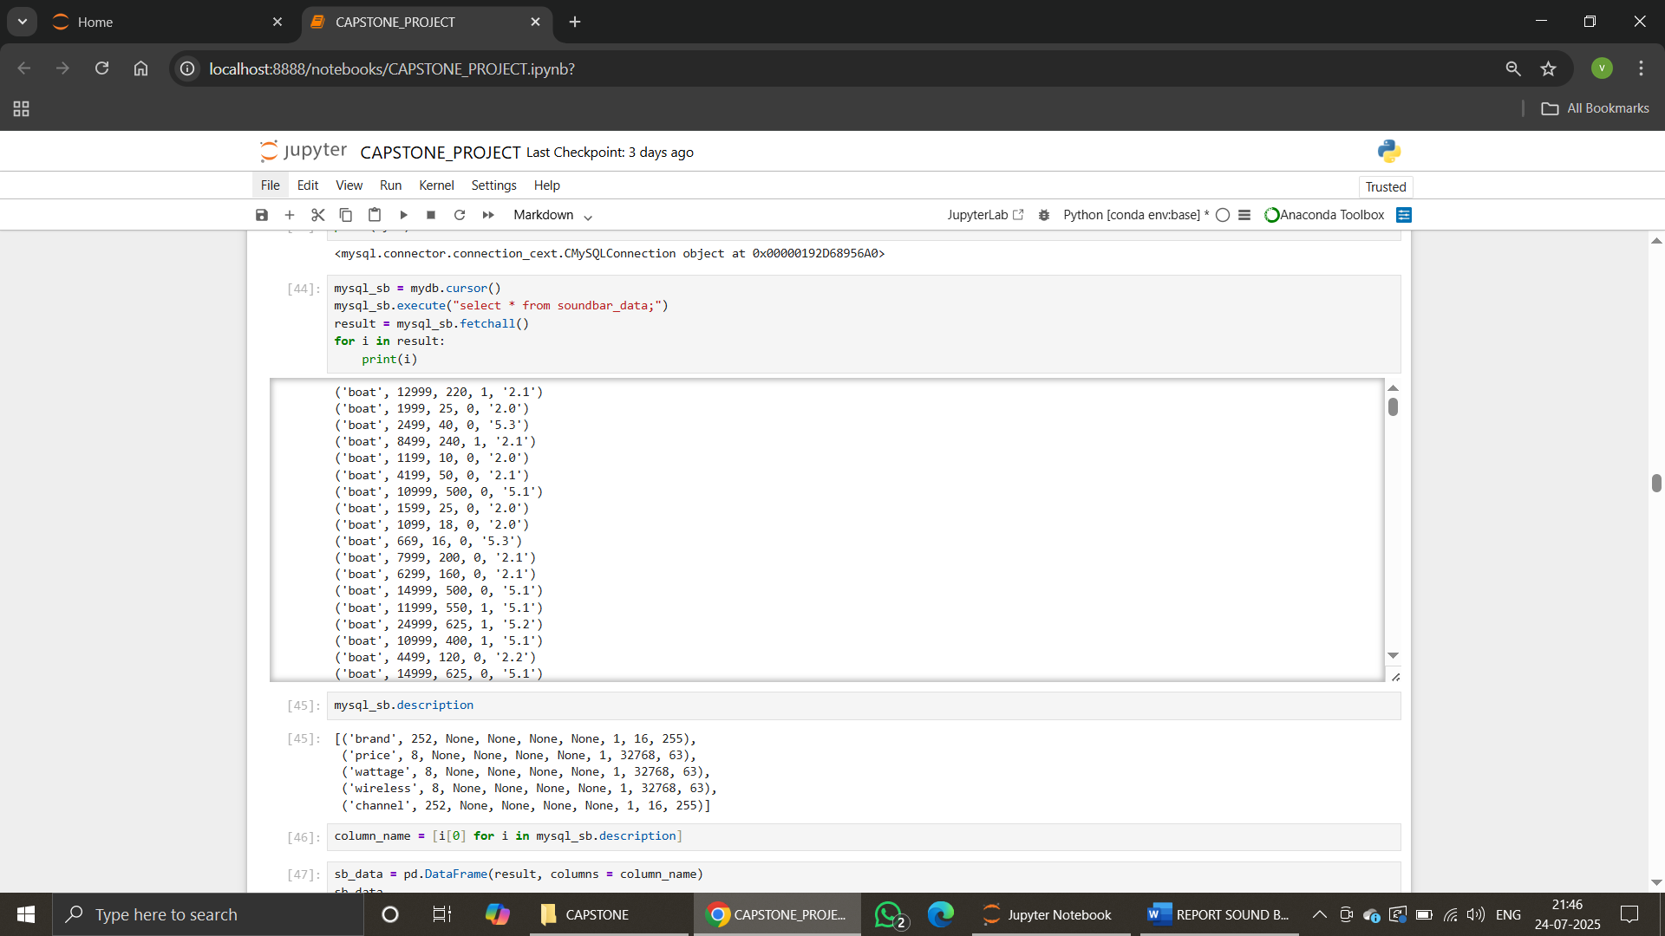

EXPLORATORY DATA ANALYSIS
Exploratory Data Analysis was performed to gain a comprehensive understanding of the dataset's structure, feature distributions, and inter-variable relationships. Visual tools such as bar charts, histograms, box plots, and pair plots were utilized to identify patterns, detect anomalies, assess feature variability, and evaluate category distributions. This step provided valuable insights that informed feature selection, guided preprocessing strategies and laid the groundwork for effective modelling.
UNIVARIATE ANALYSIS: Univariate statistical analysis was conducted on key numerical variables such as price, ratings and wattage. This involved assessing central tendencies, spread, and potential outliers, which were further visualized using boxplots and histograms. The analysis helped in understanding individual feature behaviour and detecting skewness or anomalies
- BRAND DISTRIBUTION
A count plot was plotted to examine the distribution of soundbar products across different brands. This analysis highlighted the most frequently occurring brands in the dataset, helping identify key manufacturers dominating the market space.
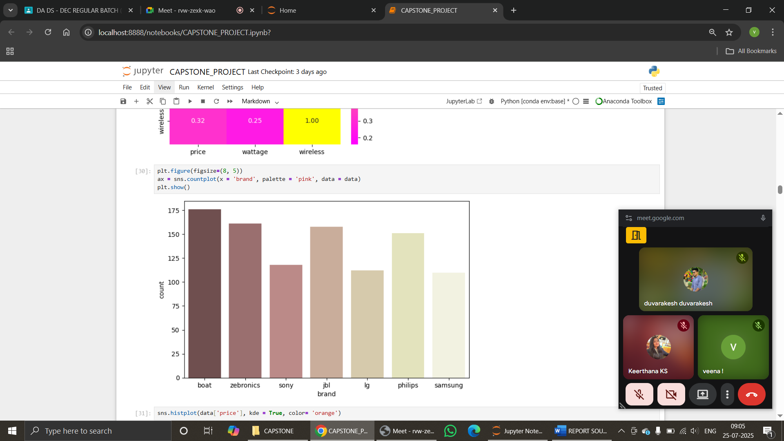
- PRICE DISTRIBUTION
A histogram of product prices was plotted to visualize the pricing structure. The data revealed a right-skewed distribution, indicating that while most soundbars fall within an affordable range, there are a few high-priced premium models that act as outliers making price skewed.
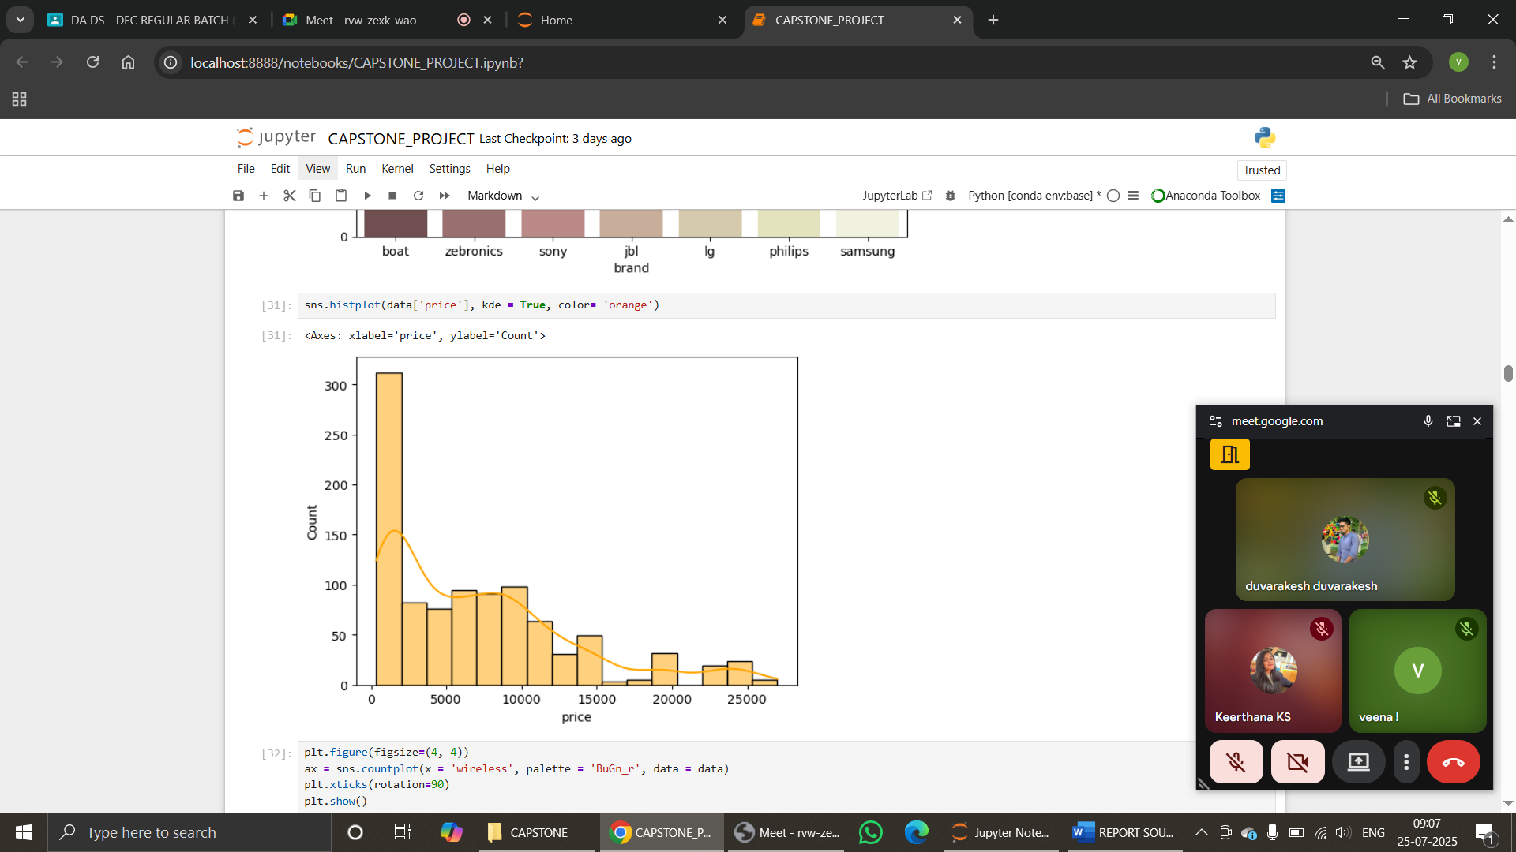
- WIRELESS TYPE COUNT DISTRIBUTION
A binary count plot was used to assess the presence “1” or absence “0” of wireless functionality in soundbar models. The plot showed a strong prevalence of wireless-enabled products, underlining consumer preference for Bluetooth and Wi-Fi-enabled devices.
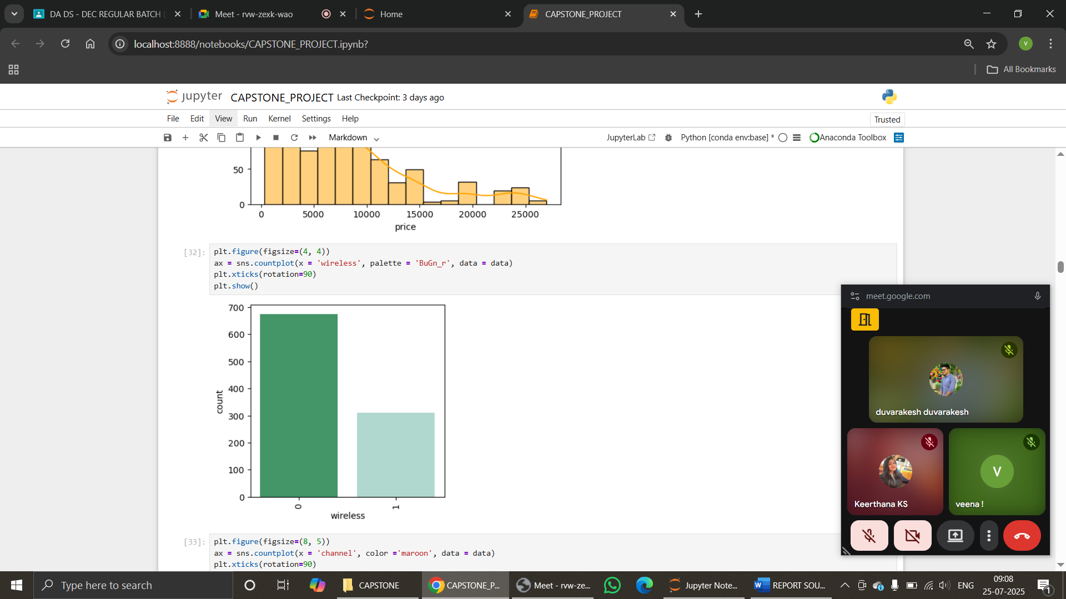
- CHANNEL CONFIGURATION DISTRIBUTION
A categorical count plot of audio channel configurations was created. The plot indicated that 2.1 and 5.1 channels were the most commonly available formats, reflecting their popularity in home entertainment setups.
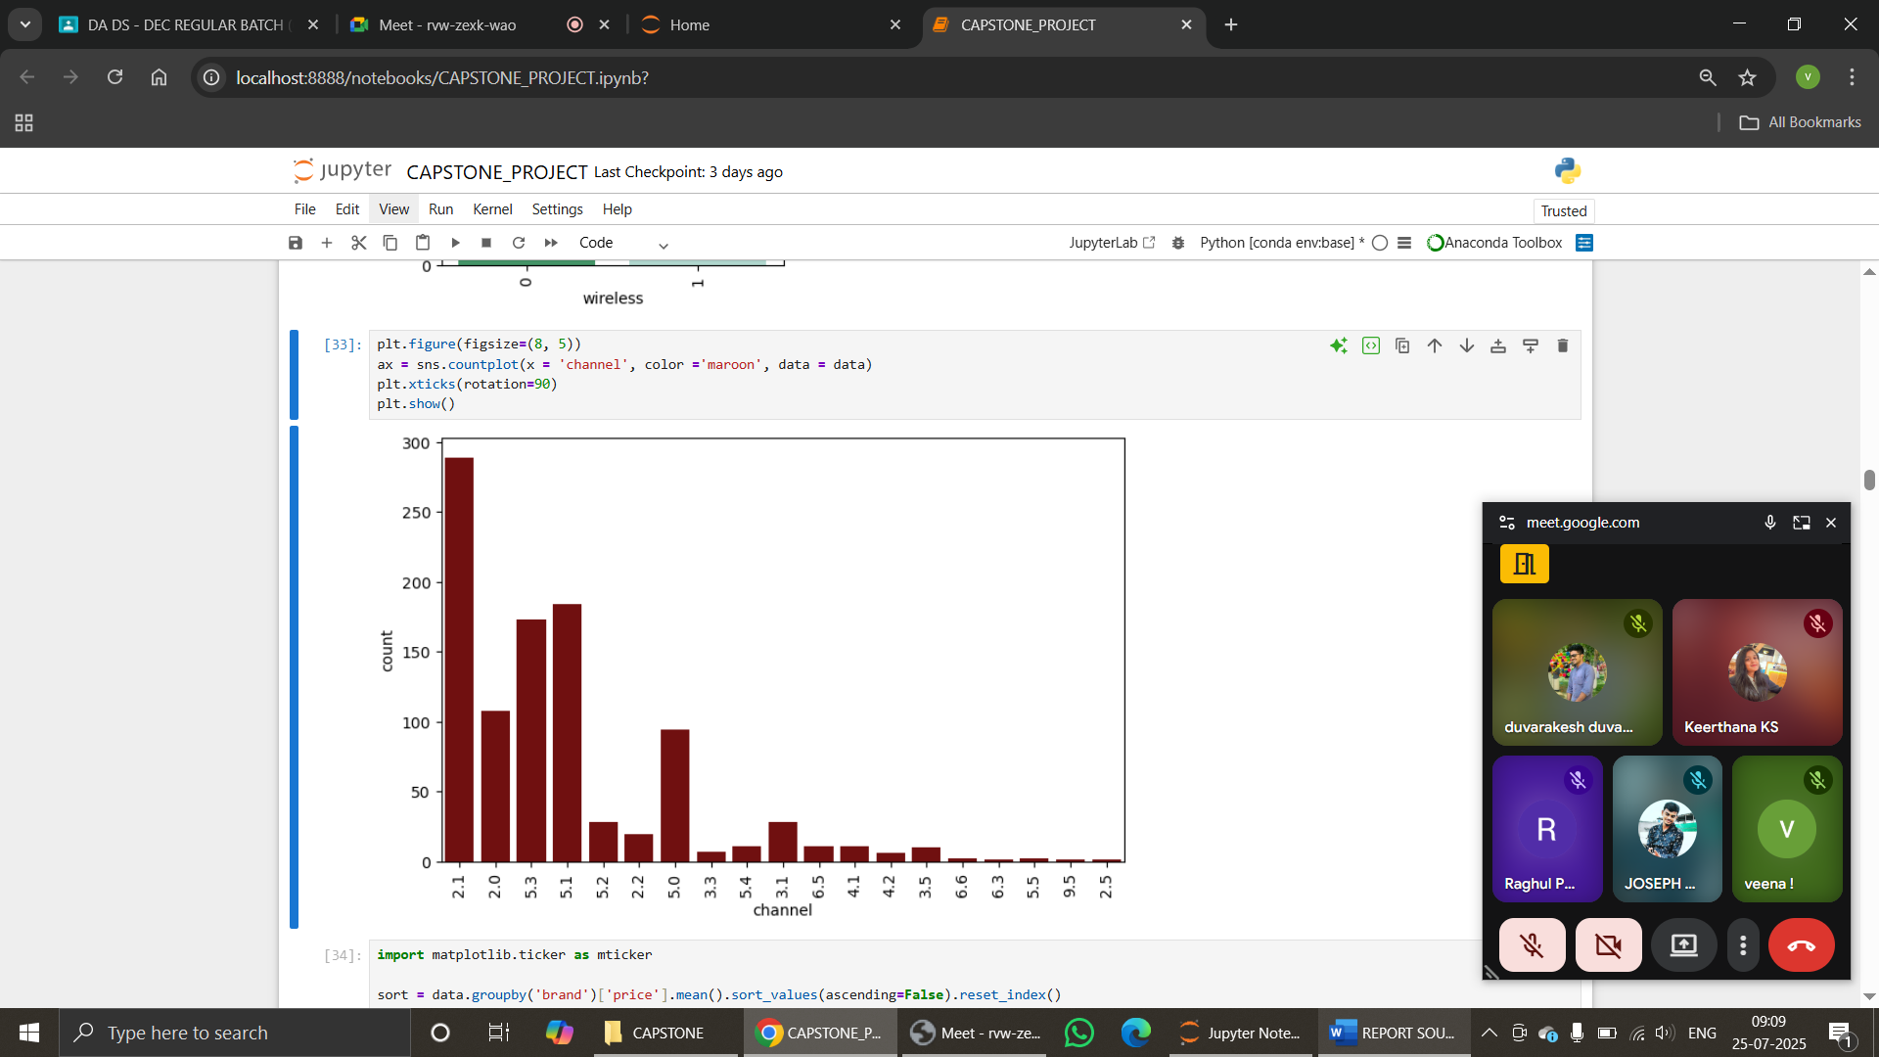

BIVARIATE ANALYSIS: Bivariate analysis is a statistical method that investigates the relationship between two variables, explores how one variable is associated with another, helping identify correlations, trends or group-wise differences.
- AVERAGE PRICE VS BRAND
A bar plot to display the average price of soundbars for each brand. This analysis helps identify which brands offer premium products and which falls to budget segments. Brands like Boat or Sony may show higher average prices, indicating a high-end product range.
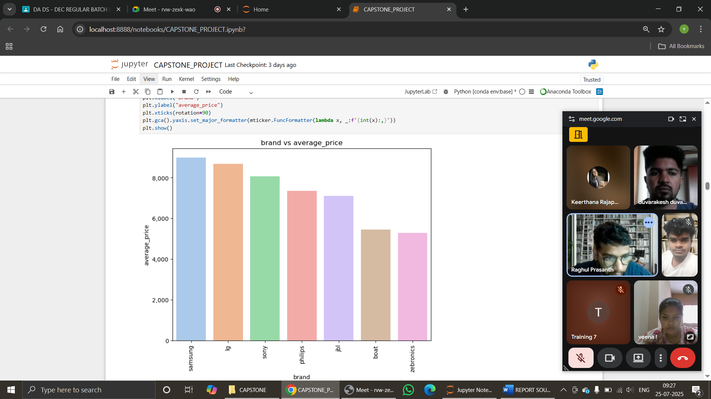
- AVERAGE PRICE VS CHANNEL CONFIGURATION
Observed that soundbars with advanced channel configurations tend to be priced significantly higher, reflecting enhanced audio capabilities.
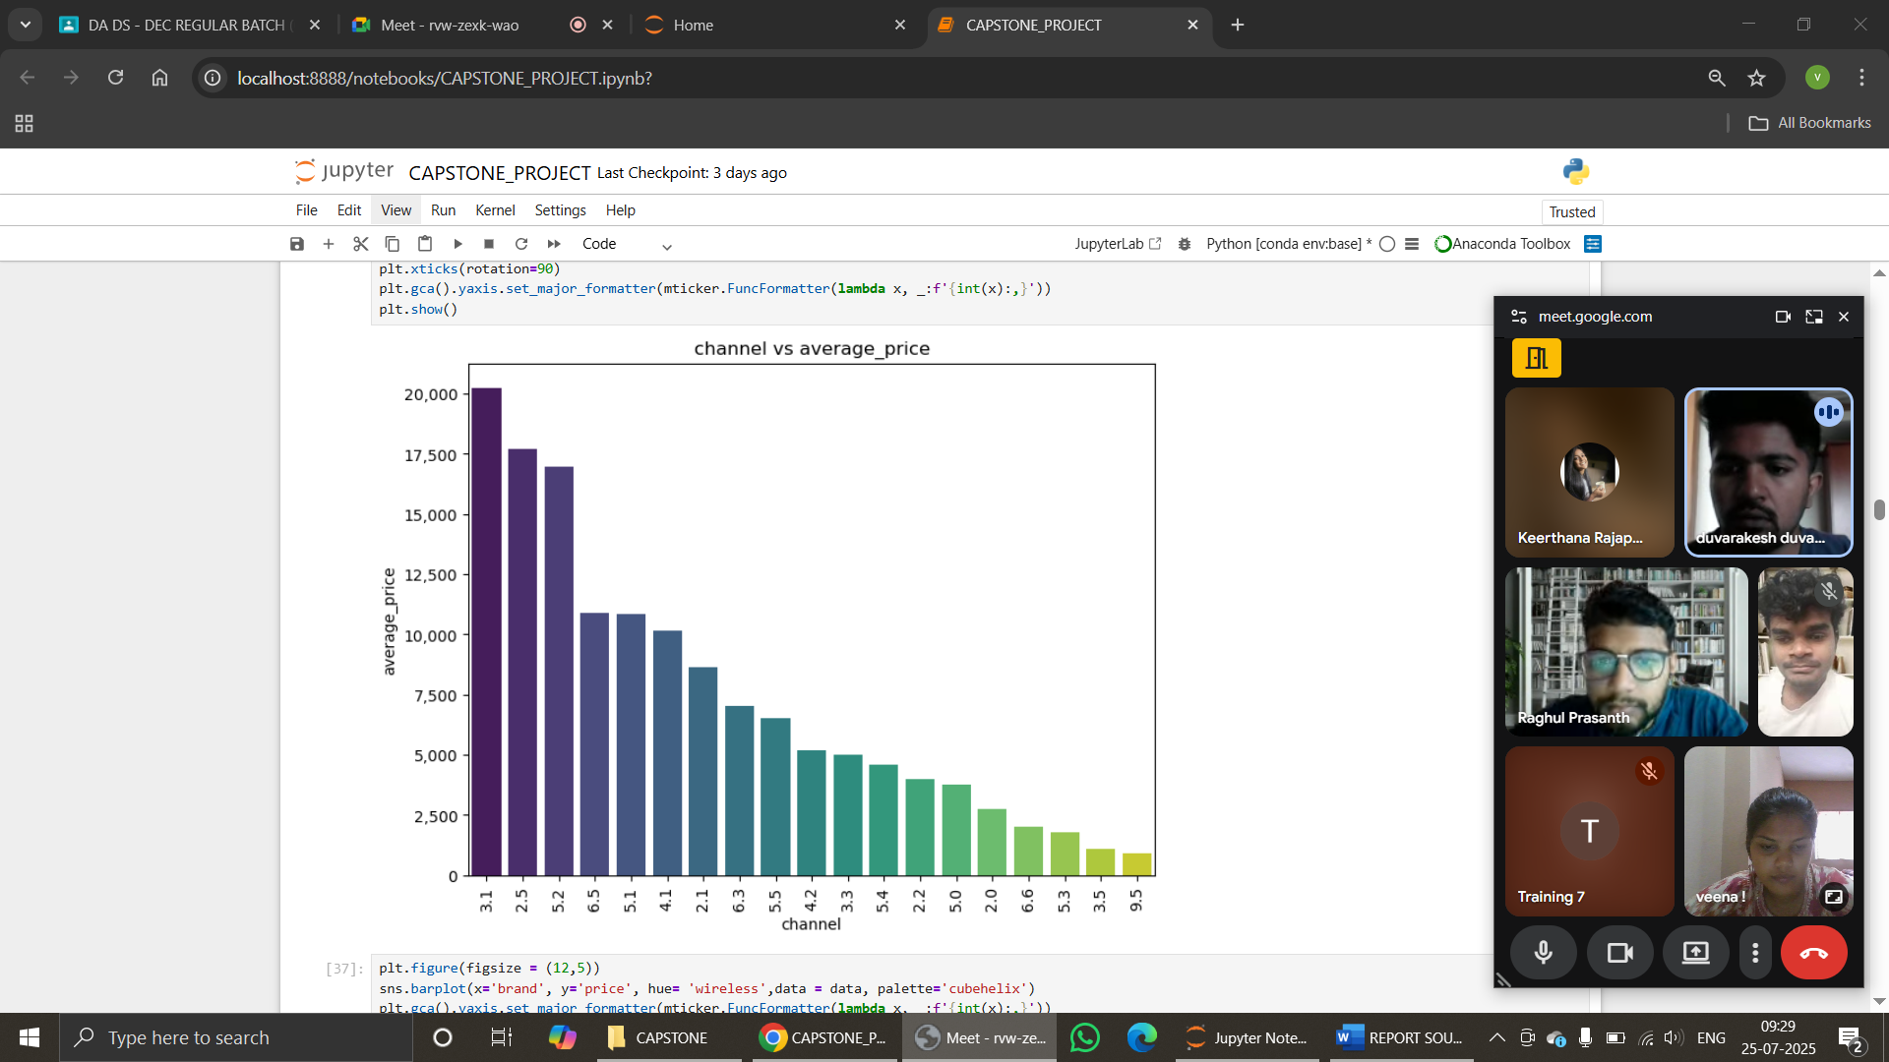
MULTIVARIATE ANALYSIS: Multivariate analysis is a statistical and exploratory technique used to examine three or more variables simultaneously to understand complex relationships among them.
- PRICE VS WIRELESS VS BRAND
Wireless-enabled soundbars generally had a higher average price across most brands. Premium brands like Sony, JBL or Boat showed a significant price gap between wireless and non-wireless models. Budget brands may have offered wireless features at a lower price point, but with trade-offs in performance or channel quality.
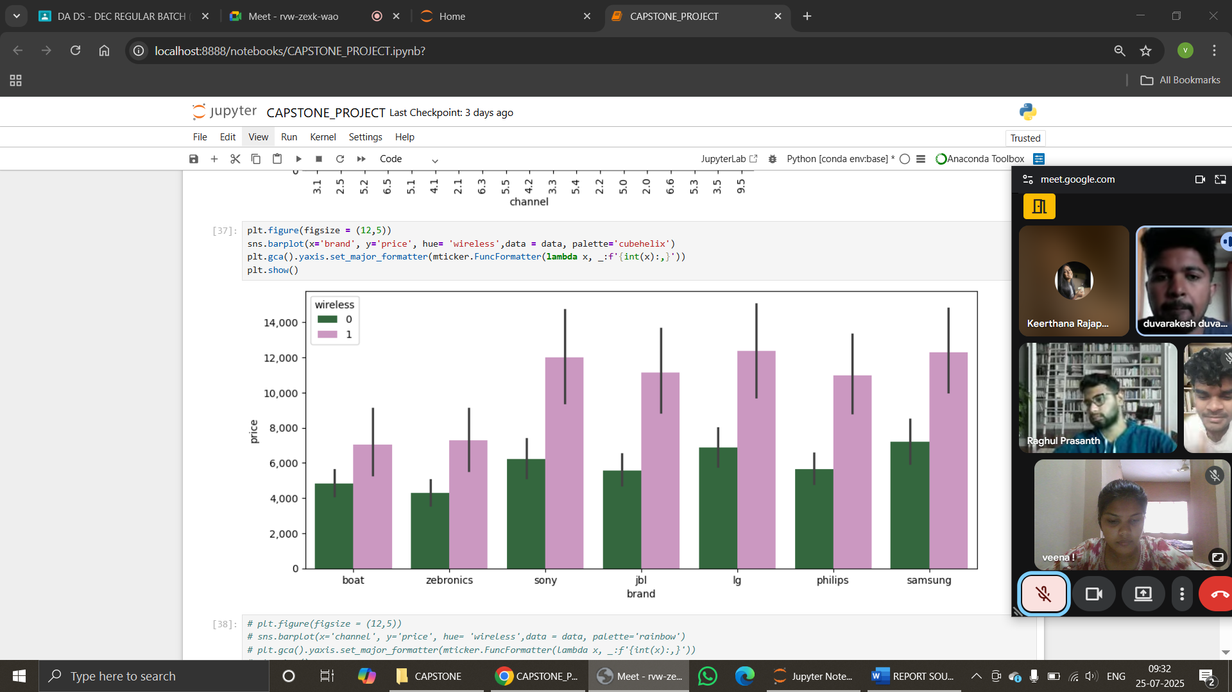
DATA PREPROCESSING: Unsupervised learning methods such as Principal Component Analysis - PCA and KMeans Clustering, require data to be in a fully numeric and standardized form, categorical features such as Brand, Channel and Wireless were encoded numerically using Label Encoding. Only relevant numerical features were selected for clustering to avoid noise and irrelevant information. Price, Wattage, Encoded Brand, Channel Configuration. This ensured that clustering captured real and interpretable features.
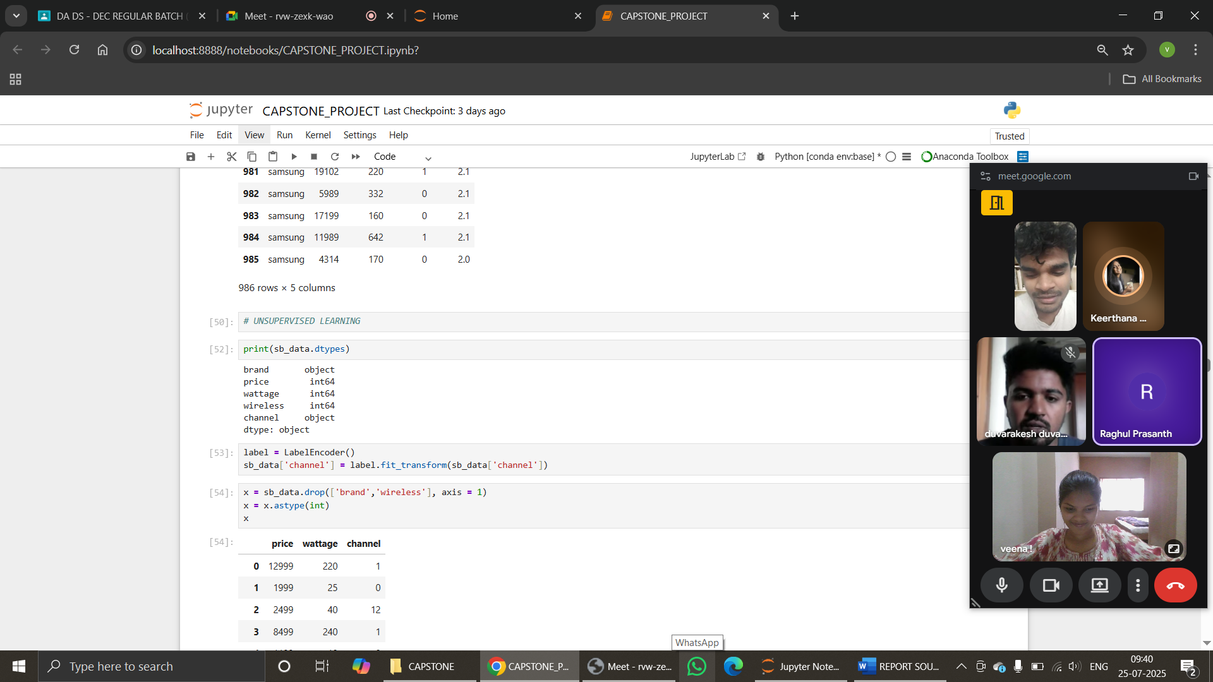
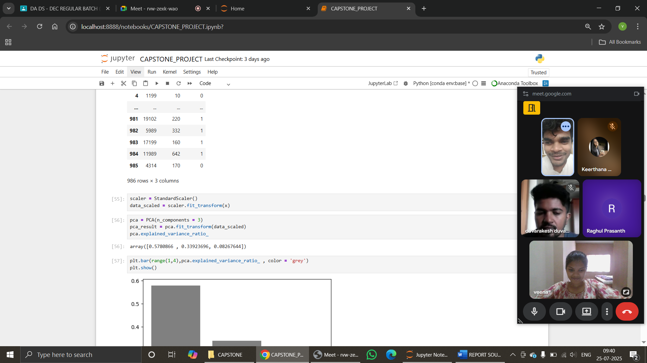
UNSUPERVISED LEARNING
Principal Component Analysis (PCA) was applied to reduce dimensionality while retaining maximum variance. KMeans clustering was performed to identify natural groupings in the data. Elbow method and silhouette analysis were used to determine the optimal number of clusters. The discovered clusters were interpreted and assigned labels for use in supervised modeling.
- Clusters formed – three
- Silhouette score – 0.58 (no overlapping)
- Labelling – group one, group two, group three
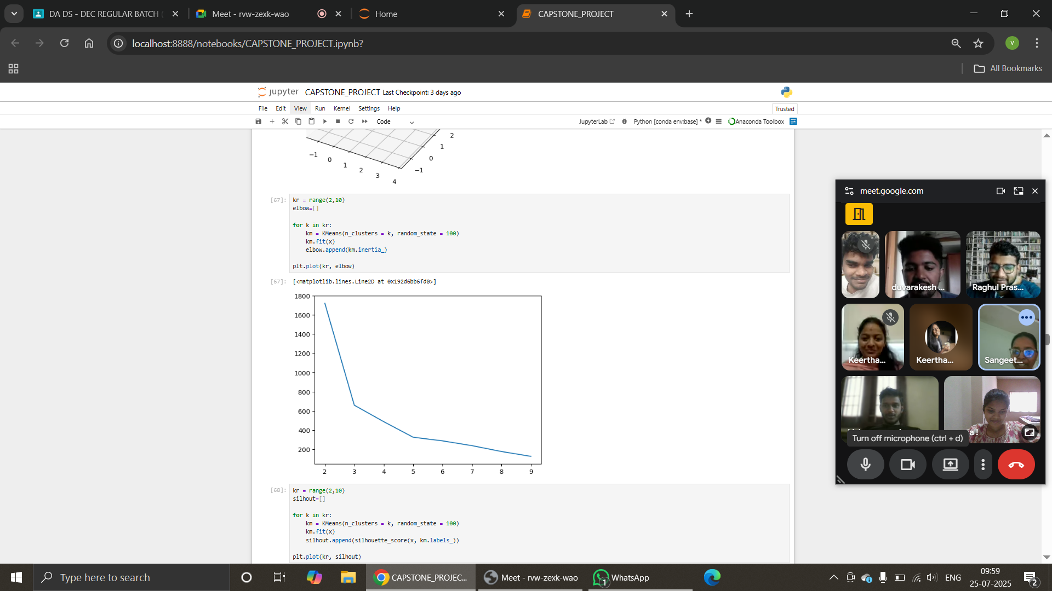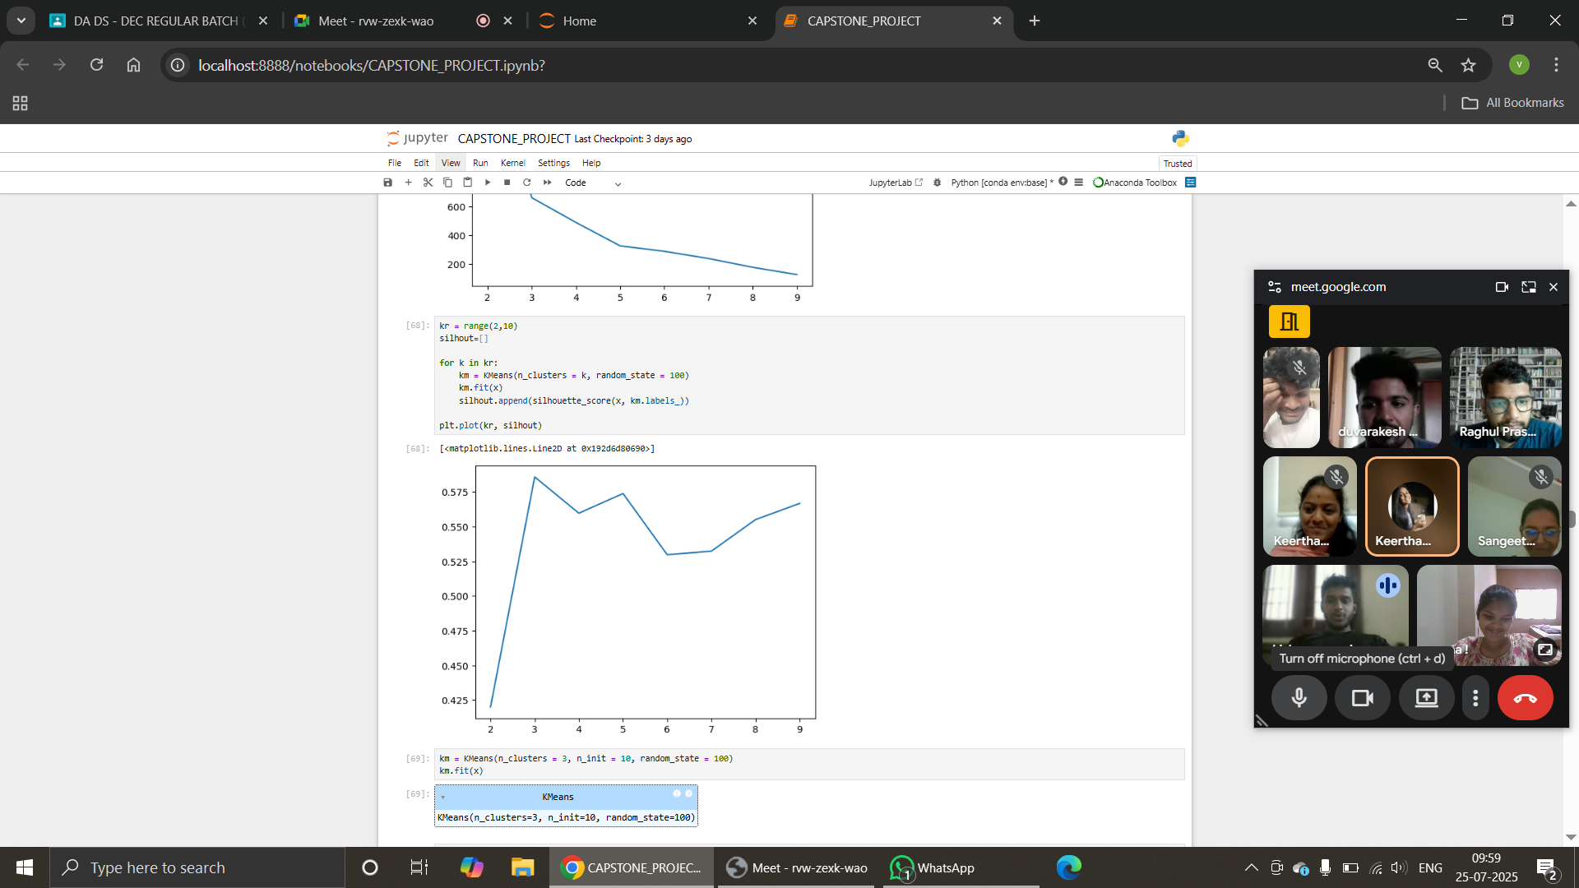
Elbow curve Silhouette curve
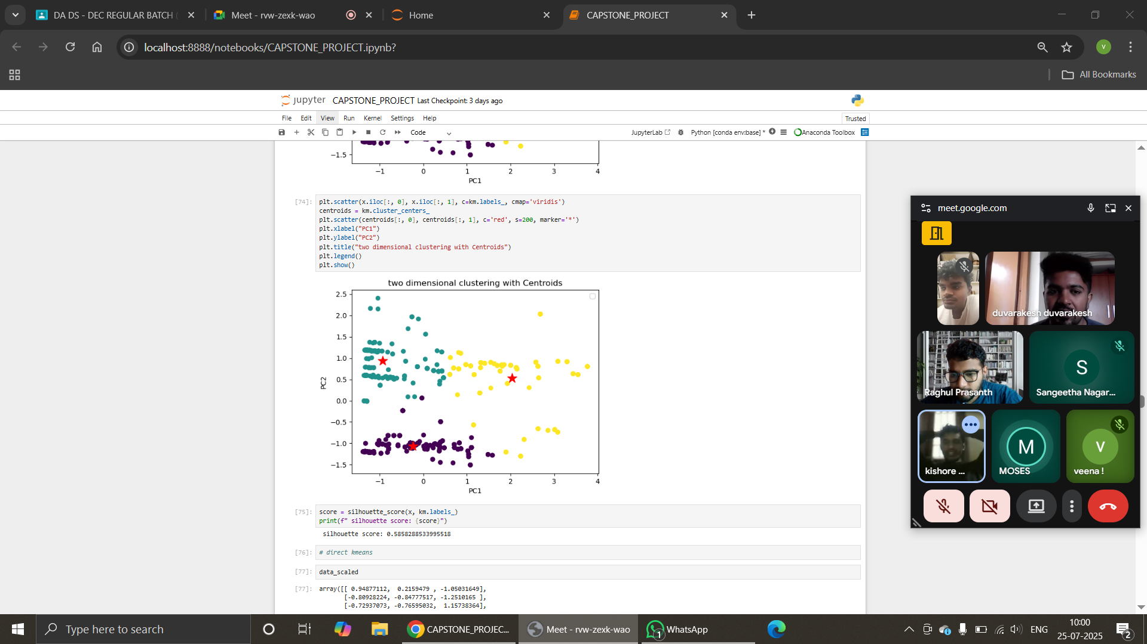
SUPERVISED LEARNING
Using the cluster assignments and other relevant features, several supervised models were trained to predict the product category.
- Logistic Regression
- K-Nearest Neighbors (KNN)
- Support Vector Machine (SVM)
- Gaussian Naive Bayes
- Decision Tree
- Random Forest
- XGBoost

Clusters,
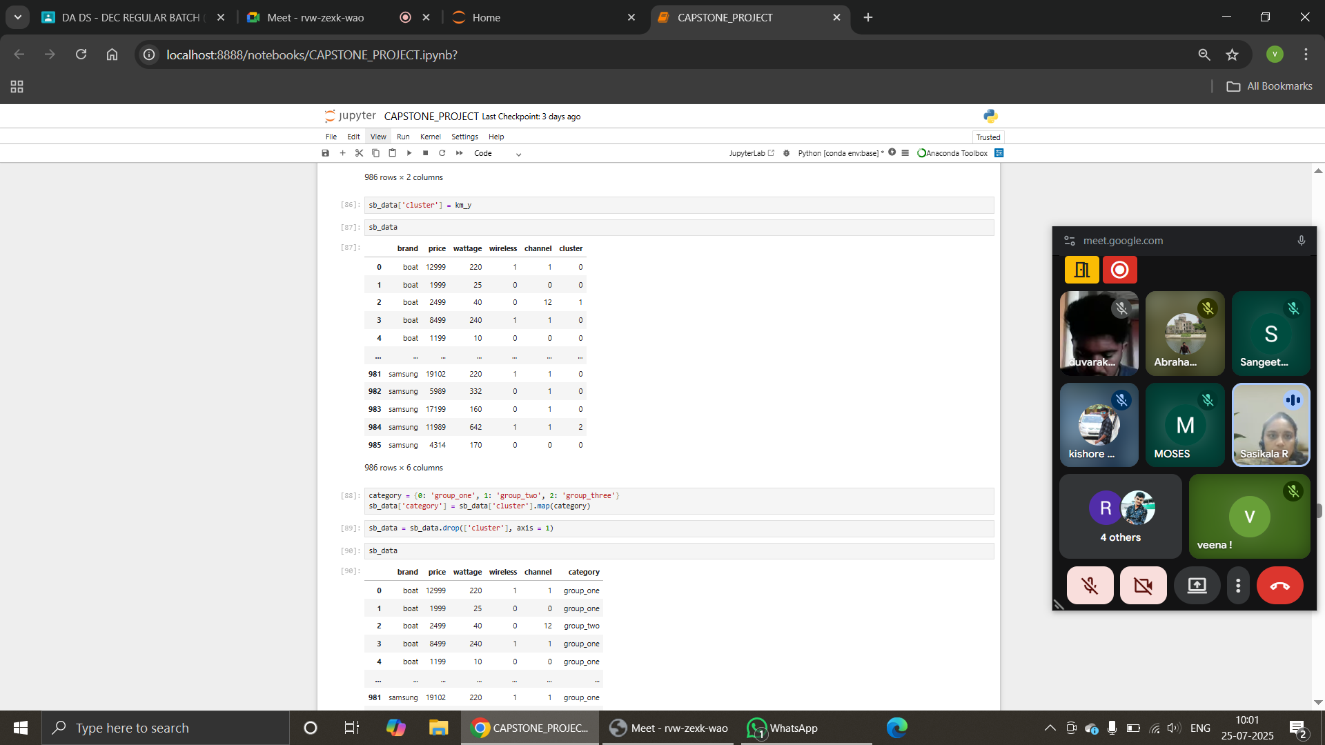

Mapping labels,
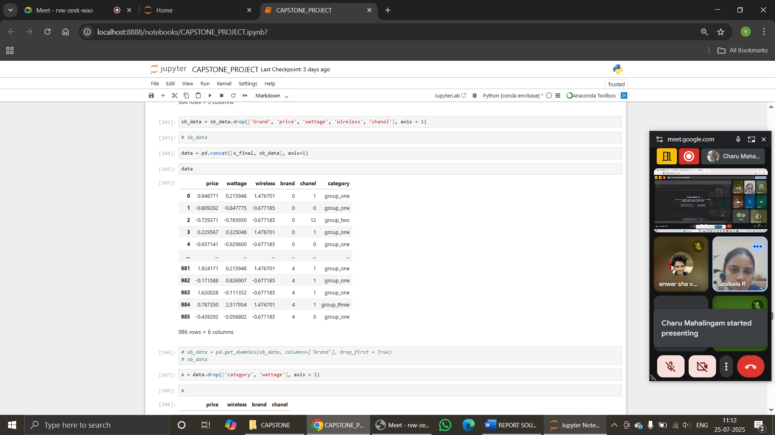
MODEL EVALUATION: Models were evaluated using training accuracy, test accuracy, and cross-validation scores. Comparative results helped select the most robust model for soundbar category prediction. Results showed strong performance from Decision Tree, Random Forest and XGBoost.
With sampling,
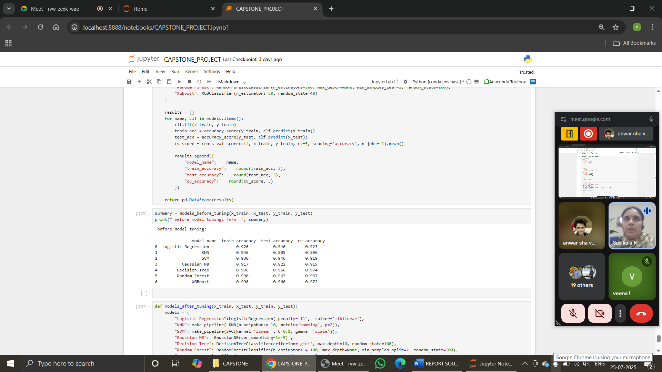
Without sampling,
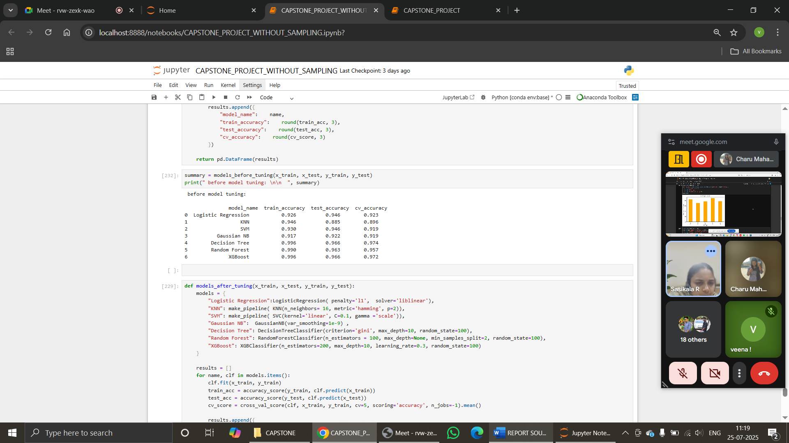

HYPERPARAMETER TUNING: GridSearchCV were used to identify optimal model parameters. Stratified K-Fold cross-validation was employed to ensure reliable and unbiased model performance evaluation.
With sampling,
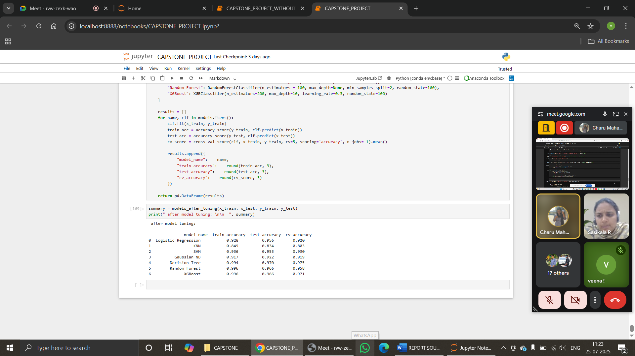
Without sampling,
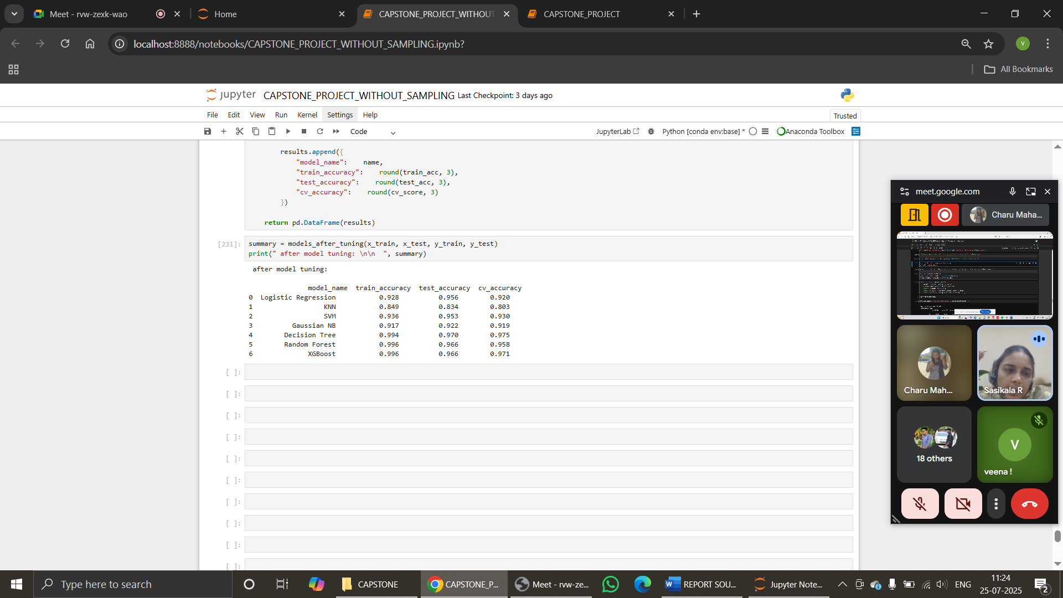

KEY INSIGHTS

- Channel configuration, Wattage and price were important predictors
- Model evaluation confirmed robustness using cross-validation
- Decision Tree and XGBoost yielded the highest performance
- Comparing Accuracies show models are generalised
- SMOTE significantly helped in mitigating class imbalance
- Clustering provided meaningful groupings reflecting features combination
- Proper encoding and scaling improved model consistency

CONCLUSION:
This project successfully demonstrated the application of end-to-end machine learning techniques on real-world e-commerce data. From web scraping and storage to clustering and classification, each step contributed toward building a robust soundbar classification system. The system enables automated product analysis, classification and market segmentation providing valuable insights for business and consumers.

FUTURE SCOPE:
- Integrate customer reviews and ratings using NLP
- Deploy the system with live scraping and prediction updates
- Expand product range
- Explore ensemble stacking for better performance
- Use advanced deep learning for image with text fusion analysis

THANK YOU

REPORTED BY,

VEENA SRI PM
DATA ANALYTICS AND DATA SCIENCE
RP – 33.

